LTT-LAR12100P2

(12.8V100Ah)
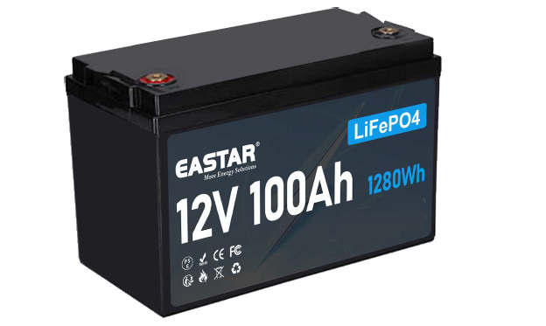

▶ Product Features
- Using the technology of lithium iron phosphate cell, superior safety, thousands of cycles, 100%DOD, under normal conditions.
- Built-in automatic protection for over-charge, over discharge, over current and over temperature.
- Free of maintenance .
- Internal cell balancing.
- Lighter weight: About 40% ~50% of the weight of a comparable lead acid battery.
- Replacement for lead-acid battery.
- Wider temperature range:-20℃~60℃.
- Support for Series application expansion (up to 25.6V)

Electrical Characteristics

Nominal Voltage 12.8V
Nominal Capacity 100Ah@0.2C
Min. Capacity 98Ah@0.2C
Nominal Energy 1280Wh
Internal Resistance ≤ 25mΩ
Cycle Life 2000 Cycles @ 20A Charging/Discharging ,Until 70% Capacity
Self Discharge ≤3.5% per month at 25℃
Bluetooth&Heat NO

Standard Charging &Discharge

Max.Charging Voltage 14.0~14.4V
Charging Mode CC-CV
Charging Current 20A
Max.Charging Current 50A
Discharging Current 50A
Max. Continuous Discharging Current 100A
Max.Pulse Discharging Current 200(A<3S)
Discharging Cut-off Voltage 10.8V

Operating Condition

Charge Temperature 0℃ to 45℃(32℉ to 113℉) @60±25% Relative Humidity
Discharge Temperature -20℃ to 60℃(-4℉ to 140℉) @60±25% Relative Humidity

Structure
Storage Temperature 0℃ to 45℃(32℉ to 113℉) @60±25% Relative Humidity

Casing Plastic
Dimension(L*W*H*TH) 260x169x210mm
Weight Approx. 10.3Kgs
Terminal M8
Water Dust Resistance IP65

Certifications

- UL1642 (Cell) ■ IEC62133 (Cell) ■ IEC62619 (Cell) ■CE (Cell) ■UN38.3 (Cell / Pack) ■ ROHS (Cell)

Version: V1.0 Date: 20-May-23 Code: 23133145

LTT-LAR12100P2

(12.8V100Ah)
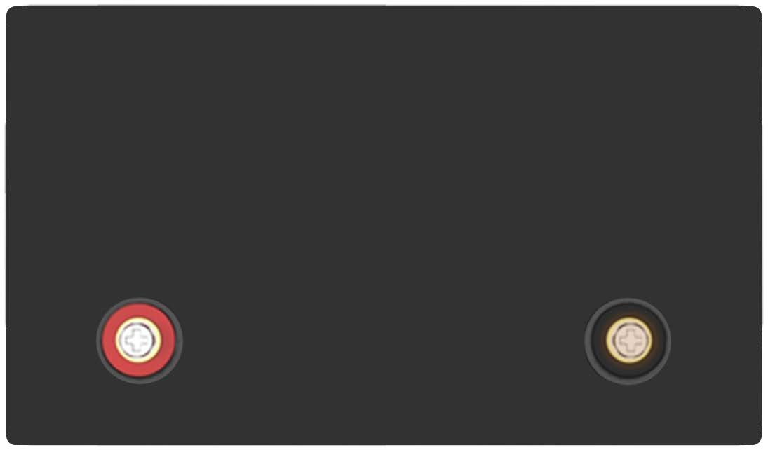
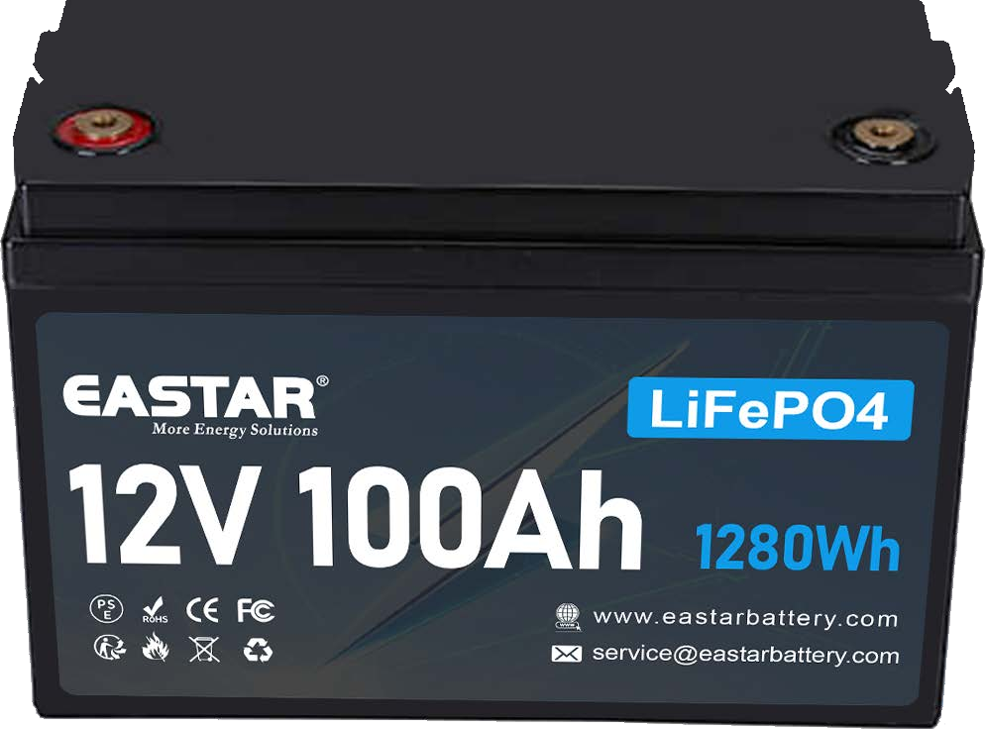
Dimensions

260mm

210mm
169mm

Characteristic Curves
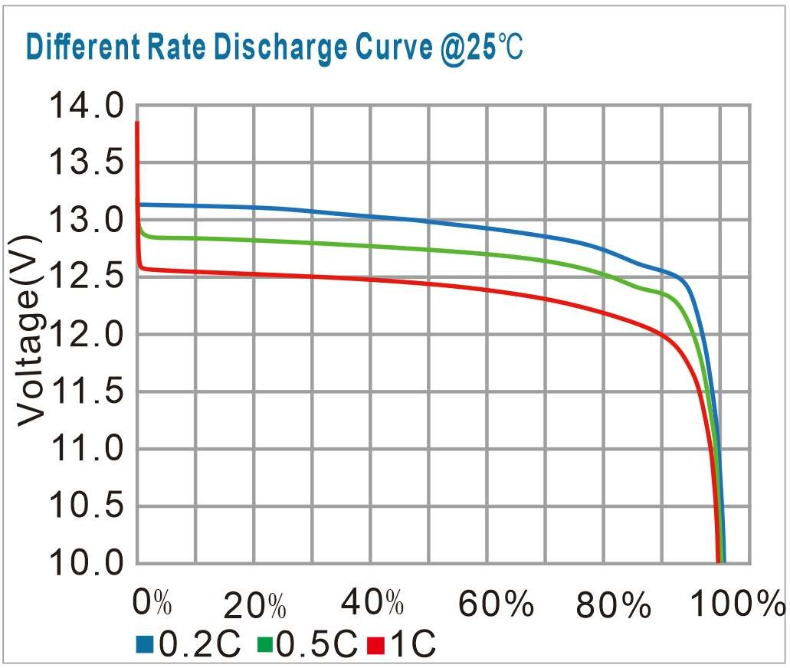
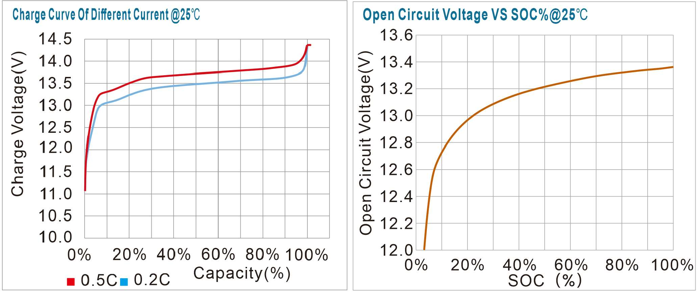

Market Application








Low-speed car Golf cart Light EV Robotics Cleaning
Solar &Wind
Lighting

